PROG6212 POE

ST10293362

Musa George Ntuli

**Submitting Claim**

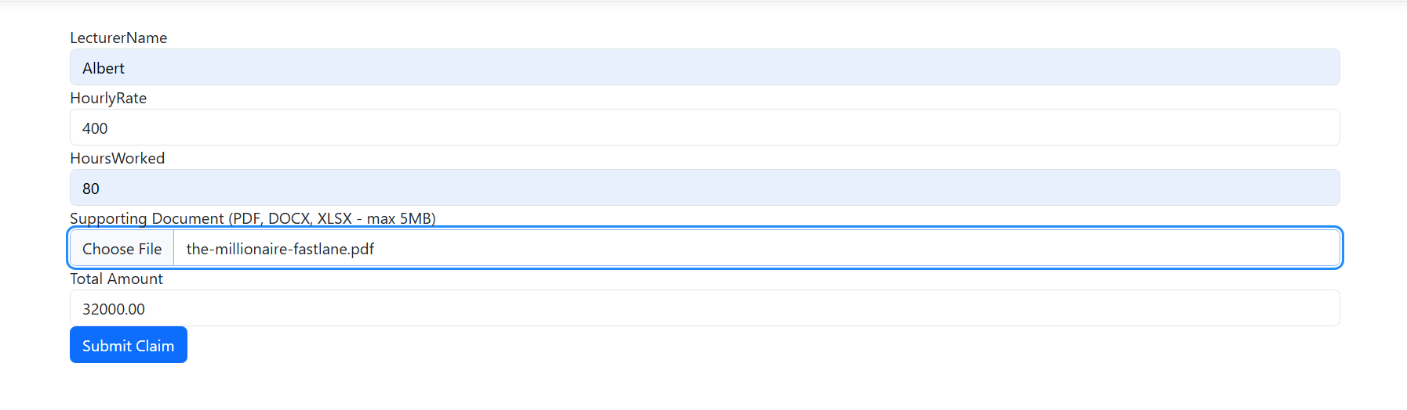 (Mrzyglod, 2022)

@model PROG6212_POE_R.Models.Claim

<**form** **asp-action**="SubmitClaim" method="post" enctype="multipart/form-data" class="my-4">

<div class="form-group">

<**label** **asp-for**="LecturerName"></**label**>

<**input** **asp-for**="LecturerName" class="form-control" required />

<**span** **asp-validation-for**="LecturerName" class="text-danger"></**span**>

</div>

<div class="form-group">

<**label** **asp-for**="HourlyRate"></**label**>

<**input** **asp-for**="HourlyRate" class="form-control" **type**="number" step="0.01" required oninput="calculateTotal()" />

<**span** **asp-validation-for**="HourlyRate" class="text-danger"></**span**>

</div>

<div class="form-group">

<**label** **asp-for**="HoursWorked"></**label**>

<**input** **asp-for**="HoursWorked" class="form-control" **type**="number" required oninput="calculateTotal()" />

<**span** **asp-validation-for**="HoursWorked" class="text-danger"></**span**>

</div>

<div class="form-group">

<label for="file">Supporting Document (PDF, DOCX, XLSX - max 5MB)</label>

<input type="file" name="file" class="form-control" accept=".pdf,.docx,.xlsx" />

<**span** **asp-validation-for**="SupportingDocument" class="text-danger"></**span**>

</div>

<div class="form-group">

<label>Total Amount</label>

<input type="text" id="totalAmount" class="form-control" readonly />

</div>

<button type="submit" class="btn btn-primary">Submit Claim</button>

</**form**>

<!--This page is used to create new claims (Troelsen and Japikse, 2022)-->

@section Scripts {

@{

await Html.RenderPartialAsync("_ValidationScriptsPartial");

}

<script>

function calculateTotal() {

var hourlyRate = parseFloat(document.getElementById('HourlyRate').value) || 0;

var hoursWorked = parseFloat(document.getElementById('HoursWorked').value) || 0;

var totalAmount = hourlyRate * hoursWorked;

document.getElementById('totalAmount').value = totalAmount.toFixed(2);

}

</script>

}

/*

REFERNCE LIST

Troelsen, A. and Japikse, P. (2022). *Pro C# 10 with .NET 6*. Apress.

Mrzyglod, K. (2022). *AZURE FOR DEVELOPERS - implementing rich azure paas ecosystems using containers, serverless... services and storage solutions*. 2nd ed. [S.l.]: PACKT PUBLISHING LIMITED.

*/

**Claim Status**

(Mrzyglod, 2022)

@model IEnumerable<PROG6212_POE_R.Models.Claim>

<h2 class="text-center my-4">Claim Status</h2>

<table class="table table-striped table-hover">

<thead class="table-dark">

<tr>

<th>Lecturer Name</th>

<th>Hourly Rate</th>

<th>Hours Worked</th>

<th>Total Payment</th>

<th>Supporting Document</th>

<th>Approval Status</th>

</tr>

</thead>

<tbody>

@foreach (var claim in Model) // this foreach is used to display all the current claims (Troelsen and Japikse, 2022)

{

<tr>

<td>@claim.LecturerName</td>

<td>@claim.HourlyRate.ToString("C")</td>

<td>@claim.HoursWorked</td>

<td>@claim.TotalPayment.ToString("C")</td>

<td><a href="@Url.Content("~/uploads/" + claim.SupportingDocument)" target="_blank" class="btn btn-secondary btn-sm">View Document</a></td>

<td>@(claim.IsApproved ? "<span class='text-success'>Approved</span>" : "Pending")</td>

</tr>

}

</tbody>

</table>/*

REFERNCE LIST

Troelsen, A. and Japikse, P. (2022). *Pro C# 10 with .NET 6*. Apress.

Mrzyglod, K. (2022). *AZURE FOR DEVELOPERS - implementing rich azure paas ecosystems using containers, serverless... services and storage solutions*. 2nd ed. [S.l.]: PACKT PUBLISHING LIMITED.

*/

**Manage Lecturer Data**

(Mrzyglod, 2022)

@model IEnumerable<PROG6212_POE_R.Models.Claim>

<h2 class="text-center my-4">Manage Lecturer Data</h2>

<table class="table table-striped table-hover">

<thead class="table-dark">

<tr>

<th>Lecturer Name</th>

<th>Email</th>

<th>Actions</th>

</tr>

</thead>

<tbody>

@foreach (var claim in Model) //this foreachloop is used to display all lecturers (Troelsen and Japikse, 2022)

{

<tr>

<td>@claim.LecturerName</td>

<td>@claim.Email</td>

<td>

<**form** **asp-action**="UpdateLecturerData" method="post" style="display:inline;">

<input type="hidden" name="id" value="@claim.Id" />

<input type="email" name="email" value="@claim.Email" required />

<button type="submit" class="btn btn-primary btn-sm">Update Email</button>

</**form**>

</td>

</tr>

}

</tbody>

</table> <!--This page is used to manage all lecturer data accordingly (Troelsen and Japikse, 2022)-->

REFERNCE LIST

Troelsen, A. and Japikse, P. (2022). *Pro C# 10 with .NET 6*. Apress.

Mrzyglod, K. (2022). *AZURE FOR DEVELOPERS - implementing rich azure paas ecosystems using containers, serverless... services and storage solutions*. 2nd ed. [S.l.]: PACKT PUBLISHING LIMITED.

*/

**View Invoices**

(Mrzyglod, 2022)

@model IEnumerable<PROG6212_POE_R.Models.Invoice>

<h2 class="text-center my-4">Invoices</h2>

<table class="table table-striped table-hover">

<thead class="table-dark">

<tr>

<th>Invoice ID</th>

<th>Lecturer Name</th>

<th>Email</th>

<th>Total Amount</th>

<th>Invoice Date</th>

<th>Actions</th>

</tr>

</thead>

<tbody>

@foreach (var invoice in Model)//this foreach loop is for viewing all approved claims(Troelsen and Japikse, 2022)

{

<tr>

<td>@invoice.InvoiceId</td>

<td>@invoice.LecturerName</td>

<td>@invoice.Email</td>

<td>@invoice.TotalAmount.ToString("C")</td>

<td>@invoice.InvoiceDate.ToShortDateString()</td>

<td>

<a href="@Url.Action("GeneratePdfInvoice", "Claims", new { id = invoice.InvoiceId })" class="btn btn-info btn-sm">Download PDF</a>

</td>

</tr>

}

</tbody>

</table>

REFERNCE LIST

Troelsen, A. and Japikse, P. (2022). *Pro C# 10 with .NET 6*. Apress.

Mrzyglod, K. (2022). *AZURE FOR DEVELOPERS - implementing rich azure paas ecosystems using containers, serverless... services and storage solutions*. 2nd ed. [S.l.]: PACKT PUBLISHING LIMITED.

*/

(Mrzyglod, 2022)

**Home Page**

(Mrzyglod, 2022)

@{

ViewData["Title"] = "Home Page";

}

<div class="text-center my-4">

<h1 class="display-4">The Claim System's Harbour</h1>

<p>The Contract Monthly Claim System stands as a testament to innovation in administrative processes, offering a glimpse into the future of streamlined claim management. With its user-centric design and seamless integration of features, the CMCS aims to revolutionize the way claims are processed and approved. By automating repetitive tasks and providing intuitive interfaces, the system empowers both lecturers and administrators to focus on more strategic initiatives, ultimately enhancing organizational efficiency and productivity.</p>

<p>Explore the functionalities of our application:</p>

<div class="btn-group" role="group" aria-label="Quick Access">

<a href="@Url.Action("SubmitClaim", "Claims")" class="btn btn-primary">Create Claim</a>

<a href="@Url.Action("ManageLecturerData", "Claims")" class="btn btn-secondary">Manage Lecturer Data</a>

<a href="@Url.Action("ViewInvoices", "Claims")" class="btn btn-success">View Invoices</a>

</div>

</div>

REFERNCE LIST

Troelsen, A. and Japikse, P. (2022). *Pro C# 10 with .NET 6*. Apress.

Mrzyglod, K. (2022). *AZURE FOR DEVELOPERS - implementing rich azure paas ecosystems using containers, serverless... services and storage solutions*. 2nd ed. [S.l.]: PACKT PUBLISHING LIMITED.

*/

**REFERENCE LIST**

Mrzyglod, K. (2022). *AZURE FOR DEVELOPERS - implementing rich azure paas ecosystems using containers, serverless... services and storage solutions*. 2nd ed. [S.l.]: PACKT PUBLISHING LIMITED.

Troelsen, A. and Japikse, P. (2022). *Pro C# 10 with .NET 6*. Apress.